DEEP LEARNING BASED ROAD POTHOLE DETECTION AND MONITORING SYSTEM

A MAJOR PROJECT REPORT

Submitted by
BATHI BHARGAV (Regd.No.22891A0576)
SURA VARSHITHA (Regd.No.22891A05C3)
A.PRASHANTH (Regd.No.22891A0568)
SIDDARTHA (Regd.No.22891A0588)

Under the guidance of

Mr. MD. CHAND PASHA
Assistant Professor

in partial fulfillment for the award of the degree of

BACHELOR OF TECHNOLOGY
in
COMPUTER SCIENCE AND ENGINEERING



JUNE, 2025


DEPARTMENT OF COMPUTER SCIENCE & ENGINEERING

VISION
To emerge as a premier center for education and research in computer science and engineering in transforming students into innovative professionals of contemporary and future technologies to cater to the global needs of human recourses for IT and ITES companies.
MISSION
- To produce excellent computer science professionals by imparting quality training, hands-on-experience and value based education.
- To strengthen links with industry through collaborative partnerships in research & product development and student internships.
- To promote research based projects and activities among the students in the emerging areas of technology.
- To explore opportunities for skill development in the application of computer
Science among rural and under privileged population


DEPARTMENT OF COMPUTER SCIENCE AND ENGINEERING CERTIFICATE

This is to certify that the project work titled Deep Learning Based Road Pothole Detection and Monitoring System submitted by Mr. Bathi Bhargav (Regd.No.22891A0576), Ms. Sura Varshitha (Regd.No.22891A05C3), Mr. A. Prashanth (Regd.No.22891A0568), Mr Siddartha(Regd.No.22891A0588) in partial fulfillment of the requirements for the award of the degree of Bachelor of Technology in Computer Science and Engineering to the Vignan Institute of Technology And Science, Deshmukhi is a record of bonafide work carried out by our students under my guidance and supervision.
The results embodied in this project report have not been submitted in any university for the award of any degree and the results are achieved satisfactorily.

Mr. MD. Chand Pasha  Assistant Professor | Dr. G. Raja Vikram Professor & HOD, CSE
GUIDE

External Examiner

DECLARATION

We hereby declare that project entitled Deep Learning Based Road Pothole Detection and Monitoring System is bonafide work duly completed by us. It does not contain any part of the project or thesis submitted by any other candidate to this or any other institute of the university.
All such materials that have been obtained from other sources have been duly acknowledged.

BATHI BHARGAV
(Regd.No.22891A0576)

SURA VARSHITHA
(Regd.No.22891A05C3)

A. PRASHANTH
(Regd.No.22891A0568)

SIDDARTHA
(Regd.No.22891A0588)

ACKNOWLEDGEMENT
Every project big or small is successful largely due to the effort of a number of wonderful people who have always given their valuable advice or lent a helping hand. We sincerely appreciate the inspiration; support and guidance of all those people who have been instrumental in making this project a success.
We thank our beloved Chairman, Dr. L.Rathaiah Sir, who gave us great encouragement to work.
We thank our beloved CEO, Mr. Boyapati Shravan Sir, we remember him for his valuable ideas and facilities available in college during the development of the project.

We convey our sincere thanks to Dr. G. Durga Sukumar Sir, Principal of our institution for providing us with the required infrastructure and a very vibrant and supportive staff.
We would like to thank our Head of the Department , Dr. G. Raja Vikram, a distinguished and eminent personality, whose strong recommendation, immense support and constant encouragement has been great help to us. We intensely thank him for the same.
We would like to express our sincere appreciations to our project coordinators Dr.G.Janardhan sir & Dr.Manoj Kumar Mahto sir for their guidance, continuous encouragement and support during the project.
We would like to thank to thank our guide of the project, Dr. G. Janardhan sir who has invested his full effort in guiding the team in achieving the goal.
Special thanks go to my team mates, who helped me to assemble the parts and gave suggestions in making this project. We have to appreciate the guidance given by other supervisor as well as the panels especially in our project presentation that has improved our presentation skills thanks to their comment and advice's. We take this opportunity to thank all our lecturers who have directly or indirectly helped our project. We pay our respects and love to our parents and all other family members and friends for their love and encouragement throughout our career.

BATHI BHARGAV
(Regd.No.2891A0576)
SURA VARSHITHA
(Regd.No.22891A05C3)
A. PRASHANTH
(Regd.No.22891A0568)

SIDDARTHA
(Regd.No.22895A0588)

ABSTRACT

Road potholes are a major issue affecting transportation safety, vehicle performance, and road infrastructure maintenance. If not detected and repaired on time, potholes can lead to accidents, vehicle damage, and traffic congestion. Traditional pothole detection methods rely on manual inspection, which is time-consuming, labor-intensive, and often inefficient. Therefore, there is a need for an automated system that can detect potholes accurately and efficiently.
This project proposes a Deep Learning Based Road Pothole Detection and Monitoring System using YOLO (You Only Look Once), a real-time object detection algorithm used in computer vision. The system automatically detects potholes from road images or video streams captured through cameras. YOLO is capable of detecting objects quickly and accurately, making it suitable for real-time road monitoring applications.
In this system, road images are collected and preprocessed before being analyzed by the trained YOLO model. The model identifies potholes by drawing bounding boxes around the damaged regions in the image. Once detected, the pothole information can be recorded and monitored, helping authorities identify damaged road sections and plan maintenance activities.
The proposed system improves pothole detection accuracy, reduces manual inspection efforts, and enables faster identification of road damage. It can also be integrated with GPS and smart monitoring systems for large-scale road maintenance management.
In conclusion, the proposed system provides an efficient and automated approach for detecting and monitoring road potholes, contributing to improved road safety and better infrastructure management.
.

TABLE OF CONTENTS
ACKNOWLEDGEMENT.....................................................................................................III
ABSTRACT............................................................................................................................IV
1. INTRODUCTION................................................................................................................1
2. LITERATURE SURVEY.................................................................................................... 4
3. SYSTEM ANALYSIS...........................................................................................................8
3.1. Problem Statement…………………………………………………...………………8
3.2. Objective……………………………………………………………….…………….8
3.3. Existing System…………………………………………………….………………..9
3.3.1. Disadvantages of Existing System ......................................................... 10
3.4. Proposed System…………........................................................................................10
3.4.1 Advantages of Proposed System. ............................................................ 11
3.5. Software Requirement Specification ........................................................................ 12
3.5.1. Hardware Requirements ........................................................................ 12
3.5.2. Software Requirements………………………………………………...12
4. SYSTEM DESIGN…………………………............……..……………………………...13
4.1. Introduction………………………………………………………………………...13
4.2. Data Flow Diagrams…………………………………..….………………..……….14
4.3. UML Diagrams……………………………………………………………….…….15
4.3.1. Class Diagram………………………...………….…………………….15
4.3.2. Use Case Diagram……………………………………………………...17
4.3.3. Sequence Diagram…………………………...………………………...19
4.3.4. Activity Diagram……………………………………………………….21
4.3.5. System Architecture…………………………………………………....25
5. SYSTEM IMPLEMENTATION……………......................…………………………....26
5.1. Methodology……………………………………………...………………………...26 5.2. Modules Information………………………….…………………………………....36
5.2.1. Module Description…………………….…………..…………………36
5.3. Python Libraries………………………..…………………………………………..38
5.3.1. Libraries Description…………………………………………………..38
6. RESULTS AND DISCUSSIONS………………………………...……………………....40
6.1. Output……………………………………………………………………………....40
6.2. Comparison………………………………………………………………………....43
6.3. Performance Metrics…………………….………………………………………….44
7. SYSTEM TESTING……………………………………………………………………...47
8. CONCLUSION………………………………...………………………...……………….51 9. FUTURE SCOPE…………………………...………………………………...……….....52 REFERENCES…………………………………………………………..………………….53RESEARCH PAPER…………… …………………………………………………………55

LIST OF TABLES AND FIGURES

Fig 4.1: Data Flow Diagram of Microorganisms Classification ....................... 14
Fig 4.2: Class Diagram of Microorganisms Classification. .............................. 17
Fig 4.3: Use case Diagram of Microorganisms Classification. ........................ 19
Fig 4.4: Sequence Diagram of Microorganisms Classification. ....................... 21
Fig 4.5: Activity Diagram of Microorganisms Classification. ......................... 24
Fig 4.6: System Architecture of Microorganisms Classification. .................... 25
Fig 5.1: Data Processing Workflow… ............................................................. 26
Fig 5.2: InceptionV3 Architecture ................................................................... 36
Fig 5.3: EfficientnetB0 Architecture ................................................................ 37
Fig 5.4: Resnet50 Architecture ........................................................................ 37
Fig 6.1: Homepage of Microorganisms Classification .................................... 40
Fig 6.2: Model Overview. ................................................................................ 41
Fig 6.3: Microorganism classes and Key Characteristics. ............................... 41
Fig 6.4: Microorganism Image Upload Interface. ........................................... 42
Fig 6.5: Prediction Result Page. ....................................................................... 42 Fig 6.6: Accuracy plot of InceptionV3 ............................................................44
Fig 6.7: Confusion matrix of InceptionV3. ..................................................... 44
Fig 6.8: Confusion matrix of EfficientnetB0. .................................................. 45
Fig 6.9: Accuracy plot of Resnet50. ................................................................. 46
Fig 6.10: Confusion matrix of Resnet50........................................................... 46
Table 6.1: Comparison of CNN Algorithms in Microorganisms classification. 43
Table 7.1: Testcases of Microorganisms Classification. ................................... 50

1. INTRODUCTION

Road transportation plays a crucial role in the economic and social development of any country. It enables the movement of people, goods, and services efficiently across cities, towns, and rural areas. Well-maintained road infrastructure is essential for ensuring safe and smooth transportation. However, maintaining road quality is a major challenge for road authorities due to various factors such as heavy traffic, environmental conditions, and inadequate maintenance. One of the most common problems affecting road surfaces is the formation of potholes.
Potholes are depressions or cavities that develop on road surfaces due to continuous wear and tear. They are generally formed when water seeps into cracks on the road surface and weakens the underlying layers of the pavement. When vehicles pass over these weakened areas repeatedly, the road surface eventually breaks apart and forms potholes. Factors such as heavy rainfall, temperature changes, poor road construction, and excessive traffic loads further contribute to the formation of potholes. Over time, small cracks can develop into larger potholes if they are not detected and repaired promptly.
The presence of potholes on roads can cause several problems for road users and transportation systems. Potholes can lead to serious road accidents, particularly for motorcyclists and cyclists who are more vulnerable to sudden road surface irregularities. Vehicles that pass through potholes at high speeds may suffer damage to tires, suspension systems, and other mechanical components. This results in increased vehicle maintenance costs for drivers. In addition, potholes can cause traffic congestion and reduce driving comfort, as drivers tend to slow down or change lanes to avoid damaged sections of the road.
Traditionally, pothole detection is carried out through manual inspection by road maintenance authorities. In this method, workers travel along roads and visually inspect the road surface to identify damaged areas. Although manual inspection is widely used, it has several limitations. It requires significant manpower, time, and operational costs to monitor large road networks. Manual inspection is also not continuous, meaning potholes may remain undetected for long periods until they cause noticeable damage or accidents. This delay in identifying road damage often leads to worsening road conditions and higher repair costs.
In recent years, advancements in technology have provided new opportunities to develop automated systems for road condition monitoring. Technologies such as Artificial Intelligence, Machine Learning, and Computer Vision have shown great potential in solving real-world problems related to image analysis and object detection. Computer vision systems are capable of analyzing images and videos to identify specific patterns or objects within them. This capability can be used to detect road surface damage such as cracks and potholes automatically.
Deep learning, a subset of machine learning, has significantly improved the performance of computer vision systems. Deep learning models are designed to learn complex patterns directly from large datasets without requiring manual feature extraction. These models use neural networks with multiple layers to process image data and recognize patterns with high accuracy. Deep learning has been successfully applied in various fields such as medical imaging, autonomous driving, security surveillance, and industrial automation.
Among the different deep learning techniques used for object detection, YOLO (You Only Look Once) has gained significant attention due to its speed and accuracy. YOLO is a real-time object detection algorithm that can detect multiple objects in an image with a single pass through the neural network. Unlike traditional detection methods that analyze images in multiple stages, YOLO processes the entire image at once and predicts bounding boxes along with object classifications simultaneously. This approach makes YOLO extremely fast and suitable for applications that require real-time detection.
The YOLO algorithm divides an input image into a grid and predicts bounding boxes around objects along with their confidence scores. Each bounding box indicates the location of a detected object within the image. In the context of pothole detection, YOLO can be trained using a dataset of road images that contain potholes and normal road surfaces. By learning the visual features associated with potholes, the model can accurately detect damaged road areas in new images or video frames.
The proposed project focuses on developing a deep learning based road pothole detection and monitoring system using the YOLO object detection algorithm. In this system, road images are captured using cameras mounted on vehicles or monitoring devices. The captured images are then processed and analyzed by the trained YOLO model. The model detects potholes by drawing bounding boxes around damaged areas on the road surface. This visual identification makes it easier to understand the exact location and severity of road damage.
Once potholes are detected, the information can be recorded and stored in a monitoring system. The collected data can help road maintenance authorities identify damaged road sections and prioritize repair work. Automated detection reduces the need for manual inspections and improves the efficiency of road maintenance activities. The stored data can also be used to analyze road conditions over time and support better decision-making in infrastructure management.
Furthermore, the proposed system can be integrated with additional technologies such as GPS modules and mobile applications to provide location-based pothole detection. By combining visual detection with geographic information, authorities can map pothole locations accurately and plan maintenance activities more effectively. Such integration can also support smart city initiatives where infrastructure monitoring is performed using advanced digital technologies.
The development of an automated pothole detection system can significantly improve road safety and infrastructure management. Early detection of potholes helps prevent accidents and reduces vehicle damage. By utilizing deep learning and computer vision technologies, the proposed system provides an intelligent and efficient approach to road damage detection and monitoring.
Overall, the deep learning based road pothole detection and monitoring system using YOLO offers an effective solution for identifying potholes automatically and supporting better road maintenance planning. The system demonstrates how modern technologies can be applied to improve transportation infrastructure and contribute to safer and more reliable road networks.
.

2. LITERATURE SURVEY

1. Title: Automatic Road Damage Detection Using Deep Learning
Authors: S. Maeda, Y. Sekimoto, T. Seto, T. Kashiyama, and H. Omata
Published on: 2018 (IEEE International Conference on Big Data)
DOI: 10.1109/BigData.2018.8622084
This research proposes a deep learning-based approach for detecting road damage such as cracks and potholes using images captured from smartphone cameras. The authors used convolutional neural networks to identify different types of road damage automatically. The system collects road images and processes them using trained deep learning models to detect damaged areas. The experimental results show that the proposed model can detect road damage with high accuracy and can be deployed using mobile devices. This study highlights the potential of deep learning techniques for real-time road damage monitoring. The research also demonstrates how mobile-based data collection can support large-scale road condition monitoring. Additionally, the use of smartphone cameras reduces the cost of implementation and allows easier data collection from different locations. The study also emphasizes the importance of large training datasets for improving model performance.

2. Title: Pothole Detection Using Computer Vision and Machine Learning
Authors: S. Varadharajan, A. Jose, K. Sharma, and L. Wander
Published on: 2019 (International Journal of Engineering Research and Technology)
DOI: 10.17577/IJERTV8IS050152
This study presents a pothole detection system based on computer vision and machine learning techniques. The researchers used image processing methods combined with machine learning algorithms to identify potholes from road images. Features such as texture, edges, and shape characteristics were extracted from images and used to train the classifier. The results indicate that the system can detect potholes effectively under certain conditions. However, the accuracy is affected by lighting variations and road texture differences. The study emphasizes the need for more advanced models to improve detection performance in real-world environments. Furthermore, the research suggests that combining machine learning with large datasets can enhance the reliability of pothole detection systems. The authors also highlight the need for automated monitoring systems to reduce manual road inspections.

3. Title: Real-Time Road Pothole Detection Using YOLO Object Detection Algorithm
Authors: M. Anand, R. Prabhu, and S. Karthikeyan
Published on: 2021 (International Conference on Artificial Intelligence and Smart Systems)
DOI: 10.1109/ICAIS50930.2021.9395806
This research focuses on detecting potholes using the YOLO object detection algorithm. The proposed system processes road images captured through cameras and detects potholes in real time by drawing bounding boxes around the damaged areas. The YOLO model is trained using a dataset containing pothole images, enabling it to detect potholes quickly and accurately. The study demonstrates that YOLO-based detection systems provide high detection speed and accuracy, making them suitable for real-time road monitoring applications. The results show that real-time detection can help authorities respond quickly to road damage issues. The system can also be integrated with surveillance cameras and vehicle-mounted cameras for continuous monitoring of road conditions. The study highlights that real-time detection systems are highly beneficial for smart transportation infrastructure.

4. Title: Road Surface Damage Detection Using Deep Convolutional Neural Networks
Authors: H. Zhang, Y. Wang, and J. Liu
Published on: 2020 (IEEE Access)
DOI: 10.1109/ACCESS.2020.2985809
This paper presents a deep learning approach for detecting road surface damage using convolutional neural networks. The researchers trained a CNN model on a dataset of road images containing various types of damage such as potholes and cracks. The system analyzes road images and identifies damaged regions with improved accuracy compared to traditional methods. The results show that deep learning models can effectively learn complex patterns from road images and provide reliable detection results. This research highlights the effectiveness of CNN-based models in modern road damage detection systems. The study also shows that deep learning models can adapt to different road environments when trained with diverse datasets. Furthermore, the research indicates that deep learning techniques can significantly improve detection accuracy in complex road conditions.

5. Title: Automatic Pothole Detection System Using Computer Vision Techniques
Authors: A. Rajkumar, R. Hariharan, and P. Karthik
Published on: 2020 (International Journal of Advanced Computer Science and Applications)
DOI: 10.14569/IJACSA.2020.0110672
This research proposes an automated pothole detection system based on computer vision techniques. The system captures road images using cameras and processes them using image analysis methods to detect potholes. The researchers developed algorithms to identify pothole patterns based on texture and depth variations in road surfaces. The study highlights the importance of automated road monitoring systems in improving road maintenance and reducing accidents caused by damaged roads. The proposed method also demonstrates how computer vision can assist authorities in maintaining road infrastructure more efficiently. In addition, the research suggests that combining computer vision with deep learning can further enhance detection accuracy. The authors also recommend integrating such systems with smart city infrastructure for better road management.

3.SYSTEM ANALYSIS

3.1 Problem Statement
Road transportation is one of the most widely used modes of transportation in the world. However, the quality and safety of road infrastructure play a critical role in ensuring smooth transportation. One of the most common problems affecting road infrastructure is the formation of potholes. Potholes are depressions or cavities formed on road surfaces due to factors such as heavy traffic load, poor road construction, weather conditions, water seepage, and aging of road materials. These potholes create serious problems for road users and transportation authorities.
Potholes can lead to road accidents, vehicle damage, traffic congestion, and increased fuel consumption. Motorcyclists and small vehicle drivers are especially vulnerable to accidents caused by potholes. In many cities and rural areas, potholes remain undetected for long periods because of inefficient road monitoring systems. As a result, the condition of roads continues to deteriorate, leading to increased maintenance costs and inconvenience to the public.
Traditionally, road authorities rely on manual inspection methods to identify potholes. In this method, maintenance workers travel along roads to inspect and record road damages. However, this approach is time-consuming, labor-intensive, and inefficient for monitoring large road networks. Moreover, manual inspection cannot provide continuous monitoring of road conditions.
With the advancement of modern technologies such as computer vision and artificial intelligence, automated road monitoring systems have become possible. Deep learning techniques can analyze road images and detect road damages automatically. These technologies provide an opportunity to develop intelligent systems that can detect potholes accurately and efficiently.
Therefore, there is a need for an automated system that can detect potholes using advanced deep learning techniques. Such a system can help authorities monitor road conditions effectively and take necessary maintenance actions quickly. The proposed project focuses on developing a Deep Learning Based Road Pothole Detection and Monitoring System using the YOLO object detection algorithm to address these issues.

3.2 Objective
The main objective of the proposed project is to design and develop an intelligent system capable of automatically detecting potholes on roads using deep learning techniques. The system aims to analyze road images or video frames and identify potholes with high accuracy.
Another important objective is to implement the YOLO (You Only Look Once) object detection algorithm for real-time pothole detection. YOLO is a powerful deep learning model that can detect objects within images quickly and efficiently. By using YOLO, the system can detect potholes in real time and mark their locations using bounding boxes.
The project also aims to reduce the need for manual road inspection by automating the pothole detection process. This will help road maintenance authorities save time, reduce labor costs, and improve road monitoring efficiency. Additionally, the system aims to improve road safety by detecting potholes early and helping authorities repair them before they cause accidents.
Another objective of the project is to build a system that can be easily integrated with road monitoring cameras or vehicle-mounted cameras. This will allow continuous monitoring of road conditions in both urban and rural areas. The project also aims to provide a reliable and scalable solution that can support smart city infrastructure and intelligent transportation systems.
3.3 Existing System
In the existing system, pothole detection is mainly performed using manual inspection methods or basic sensor-based technologies. Road maintenance authorities usually rely on field workers who inspect roads physically to identify potholes and record their locations. These workers travel along road networks and observe road conditions to detect damages such as potholes and cracks.
Although manual inspection is a commonly used method, it has several limitations. It requires a large workforce and significant time to cover large road networks. In many cases, potholes are detected only after road users report them to the authorities. This delay in detection increases the risk of accidents and further road damage.
Some existing systems use sensors such as accelerometers and vibration sensors installed in vehicles to detect road irregularities. When a vehicle passes over a pothole, the sensor detects the vibration and sends information to a monitoring system. While this approach can detect potholes automatically, it requires additional hardware installation and may produce inaccurate results due to different vehicle speeds or driving conditions.
Another approach used in existing systems is traditional image processing. In this method, road images are analyzed using techniques such as edge detection, thresholding, and image segmentation to identify potholes. However, these techniques are sensitive to lighting conditions, shadows, and road surface variations. As a result, they may not perform well in real-world scenarios.
Machine learning-based systems have also been proposed in some research studies. These systems extract features from road images and use classification algorithms to identify potholes. However, such systems depend heavily on manually designed features, which limits their ability to handle complex road environments.
Due to these limitations, existing pothole detection systems are not fully efficient or reliable. Therefore, there is a need for an improved system that can detect potholes accurately and operate in real-time environments.
3.3.1 Disadvantages of Existing System
1. Time Consuming Process
In the existing system, potholes are mainly detected through manual road inspection. Road maintenance workers need to travel along roads and observe road conditions physically. This process requires a significant amount of time and effort, especially when monitoring large road networks.
2. High Labor Requirement
Manual inspection methods require a large number of workers to check road conditions regularly. This increases the operational cost for road maintenance authorities and makes the system less efficient for large-scale road monitoring.
3. Lack of Real-Time Detection
Most traditional pothole detection methods do not support real-time monitoring. As a result, potholes may remain undetected for long periods, which increases the risk of accidents and vehicle damage.
4. Inaccuracy in Sensor-Based Systems
Some existing systems use sensors such as accelerometers or vibration sensors installed in vehicles to detect potholes. However, sensor readings can vary depending on vehicle speed, suspension systems, and road conditions, which may lead to inaccurate detection.
5. Sensitivity to Environmental Conditions
Traditional image processing techniques used in some systems are highly sensitive to lighting conditions, shadows, and road surface textures. These factors can affect the accuracy of pothole detection and produce false results.
6. Limited Coverage of Road Networks
Manual inspection or sensor-based systems may not cover all roads effectively. As a result, many potholes remain unreported until road users complain about them.
7. Higher Maintenance Cost
Because potholes are not detected early, road damage may worsen over time. This leads to higher repair and maintenance costs for road authorities.
3.4 Proposed System
To overcome the limitations of existing systems, the proposed project introduces a Deep Learning Based Road Pothole Detection and Monitoring System. The system uses advanced deep learning techniques to detect potholes automatically from road images or video frames.
The proposed system uses the YOLO (You Only Look Once) object detection algorithm, which is known for its high detection speed and accuracy. YOLO processes the entire image in a single pass through the neural network and predicts bounding boxes around detected objects. This makes it suitable for real-time object detection applications.
In this system, road images are captured using cameras mounted on vehicles or installed along roads. These images are then processed using a trained YOLO model. The model analyzes each image and identifies potholes by drawing bounding boxes around them.
The system is trained using a dataset containing images of potholes and normal road surfaces. During the training phase, the YOLO model learns the visual features of potholes such as shape, texture, and depth patterns. Once the model is trained, it can detect potholes in new images with high accuracy.
The proposed system can continuously monitor road conditions and detect potholes in real time. When a pothole is detected, the system can record the detection information and store it for monitoring and maintenance purposes.
By automating the pothole detection process, the proposed system helps reduce manual inspection efforts and improve the efficiency of road maintenance operations. The system can also support smart city infrastructure by providing accurate road condition data.
3.4.1 Advantages of Proposed System
1. Real-Time Pothole Detection
The proposed system uses the YOLO object detection algorithm, which is capable of detecting potholes in real time. This enables continuous monitoring of road conditions and allows authorities to identify road damage quickly.
2. High Detection Accuracy
By using deep learning techniques, the system can learn complex features of potholes from large datasets. This improves the accuracy of pothole detection compared to traditional image processing or manual inspection methods.
3. Reduced Manual Effort
The automated detection process reduces the need for manual road inspections by maintenance workers. This helps save time and reduces the labor required for monitoring road conditions.
4. Faster Road Maintenance
Early detection of potholes helps road maintenance authorities repair damaged roads quickly. This prevents further deterioration of roads and reduces the chances of accidents.
5. Cost-Effective Solution
The proposed system mainly relies on software-based deep learning models and cameras, which reduces the need for expensive hardware installations such as multiple sensors. This makes the system more cost-effective.
6. Continuous Road Monitoring
The system can be integrated with surveillance cameras or vehicle-mounted cameras to monitor road conditions continuously. This ensures that potholes are detected even in remote or less frequently inspected areas.
7. Improved Road Safety
By detecting potholes early, the system helps prevent accidents and vehicle damage caused by poor road conditions. This contributes to safer transportation for road users.
8. Support for Smart City Infrastructure
The proposed system can be integrated with smart transportation and smart city systems. It provides useful road condition data that can help authorities plan road maintenance more effectively.

3.5. Software Requirement Specification:
A System Requirements Specification (SRS) is a crucial document that outlines the detailed requirements of a system, serving as a foundation for its development. The SRS provides a clear understanding of what the system should accomplish and defines its functionalities, constraints, and performance expectations.
Software requirements specification is essential for establishing a common understanding between stakeholders, including developers, project managers, and clients. It helps in mitigating risks, estimating project costs and timelines, and ensuring that the final product meets the desired objectives.
The SRS document includes both functional and non-functional requirements, detailing the system's behavior, capabilities, and performance characteristics. It serves as a contract between the development team and the stakeholders, guiding the development process and validating the final product. To derive accurate requirements, close collaboration and communication between the project team and stakeholders are essential. Continuous refinement and validation of requirements throughout the development lifecycle ensure that the final system meets the stakeholders' expectations.
3.5.1. Hardware requirements:
- Processor Type: Intel Core i3 or higher
- Processor Speed: 3.4 GHz or higher
- RAM: 4 GB minimum (8 GB recommended)
- Hard Disk: Minimum 500 GB storage capacity
3.5.2. Software requirements:
- Operating System: Windows 8 or later
- Integrated Development Environment (IDE) - Cloud: Google Colab
- Programming Language: Python 3.x
- Platform: Anaconda distribution
- Integrated Development Environment (IDE) - Local: Jupyter Notebook

4. SYSTEM DESIGN

4.1. Introduction
System design is an important phase in the software development process that defines the overall structure and architecture of the system. It provides a detailed description of how the system components interact with each other and how data flows through the system to achieve the desired functionality. The purpose of system design is to transform the requirements gathered during the analysis phase into a clear blueprint for implementation. A well-designed system improves efficiency, reliability, maintainability, and scalability.
In the Deep Learning Based Road Pothole Detection and Monitoring System, the system design focuses on developing an automated solution capable of detecting potholes from road images using advanced deep learning techniques. The system utilizes the YOLO (You Only Look Once) object detection algorithm, which is widely used for real-time object detection tasks. The main idea behind the design is to capture road images using cameras and process them through a trained deep learning model that can identify potholes accurately.
The system design includes multiple modules such as image acquisition, image preprocessing, pothole detection, result generation, and monitoring. The image acquisition module captures road images using cameras that may be mounted on vehicles or installed along roads. These images are then passed to the preprocessing module, where they are enhanced and prepared for analysis. After preprocessing, the images are given to the YOLO detection model, which analyzes the image and identifies potholes by placing bounding boxes around the damaged road areas.
The results generated by the detection model are then displayed to the user or stored for monitoring and analysis purposes. This information can help road maintenance authorities identify damaged road segments and schedule repair activities more efficiently. By automating the pothole detection process, the system reduces manual inspection efforts and improves road safety.
To clearly represent the structure and workflow of the system, various design diagrams are used in this chapter. These include Data Flow Diagrams (DFD) and UML diagrams such as class diagrams, use case diagrams, sequence diagrams, and activity diagrams. These diagrams help illustrate how the system components interact, how data flows through the system, and how different operations are executed during pothole detection.
The system architecture is also described to provide a clear understanding of how different modules of the system are organized and connected. It shows how input data is processed by the deep learning model and how the final detection results are produced. The design ensures that the system operates efficiently and can be easily extended in the future with improved detection models or additional monitoring features.
Overall, the system design plays a crucial role in ensuring that the pothole detection system functions effectively and meets the objectives defined during the analysis phase. By using structured design techniques and modern deep learning algorithms, the proposed system aims to provide a reliable and scalable solution for road pothole detection and monitoring.
4.2. Data Flow Diagram:

The Data Flow Diagram (DFD) illustrates the flow of data through the pothole detection system and shows how the input image is processed to detect potholes. It represents the different stages involved in analyzing road images and producing the final detection result.
The process begins with the Start stage, where the system receives a road image captured using a camera or image dataset. This image serves as the primary input to the system. Since raw images may contain noise caused by lighting conditions or camera movement, the system first applies median filtering. Median filtering helps remove noise while preserving the edges of objects in the image.
After noise removal, the image is converted into grayscale format. Grayscale conversion reduces the complexity of the image by transforming it from a colored image to a single intensity channel. This simplifies the processing and allows the system to focus on the brightness values of the image.
Next, the system performs grayscale thresholding, which separates potential pothole regions from the road surface. Thresholding identifies pixels that fall within a specific intensity range and marks them as possible pothole regions. This step helps highlight areas that require further analysis.
Once thresholding is completed, the system checks the blob size or minimum area. A blob represents a connected region in the image. This step ensures that only regions with a sufficient area are considered for further processing, eliminating very small objects that may represent noise.
The detected regions are then analyzed based on their shape characteristics. The system evaluates parameters such as circularity, convexity, and inertia. Circularity checks whether the detected region has a shape similar to a pothole. Convexity measures how closely the region resembles a convex shape, while inertia helps analyze the distribution of pixels within the region.
If the detected region satisfies the required conditions for circularity, convexity, and inertia, the system identifies the region as a pothole and generates the output “Pothole(s) Detected.” If these conditions are not satisfied, the system concludes that no pothole is present and displays “Potholes Not Detected.”
Finally, the process ends with the Finish stage, where the detection results are displayed or stored for monitoring purposes. This structured flow of data ensures that road images are processed effectively and potholes are detected accurately.

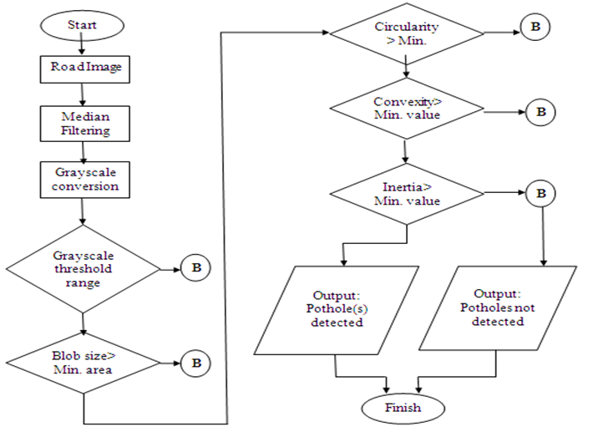

Fig 4.1: Data Flow Diagram of Pothole Detection.
4.3. UML Diagrams:

4.3.1. Class Diagram:
Class Diagram gives an overview of a software system by displaying classes, attributes, operations, and their relationships. This Diagram includes the class name, attributes, and operation in separate designated compartments.
Class diagram is a type of static structure diagram that describes the structure of a system by showing the system’s classes, their attributes, operations and the relationship among the objects.
Purpose
- Shows static structure of classifiers in a system
- Helpful for developers and other team members too
- Business analysts can use class diagram to model systems from a business perspective.

Essential elements of A UML class diagram:

- Class Name
- Attributes
- Operations

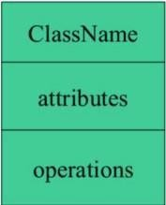

Class Name:
The name of the class is only needed in the graphical representation of the class. It appears in the topmost compartment. A class is the blueprint of an object which can share the same relationships, attributes, operations, & semantics. The class is rendered as a rectangle, including its name, attributes, and operations in sperate compartments.
Following rules must be taken care of while representing a class:
- A class name should always start with a capital letter.
- A class name should always be in the center of the first compartment.
- A class name should always be written in bold format.
- An abstract class name should be written in italics format.
Attributes:
An attribute is named property of a class which describes the object being modeled. In the class diagram, this component is placed just below the name-compartment.
A derived attribute is computed from other attributes.
Relationships:
There are mainly three kinds of relationships in UML:
- Dependencies
- Generalizations
- Associations

Dependency:
A dependency means the relation between two or more classes in which a change in one may force changes in the other. However, it will always create a weaker relationship. Dependency indicates that one class depends on another.



Generalization:
A generalization helps to connect a subclass to its superclass. A sub-class is inherited from its superclass. Generalization relationship can't be used to model interface implementation. Class diagram allows inheriting from multiple super classes.
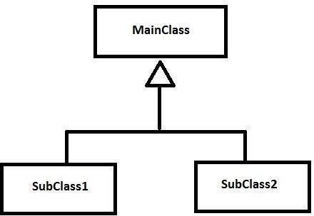

Association:
This kind of relationship represents static relationships between classes A and B.



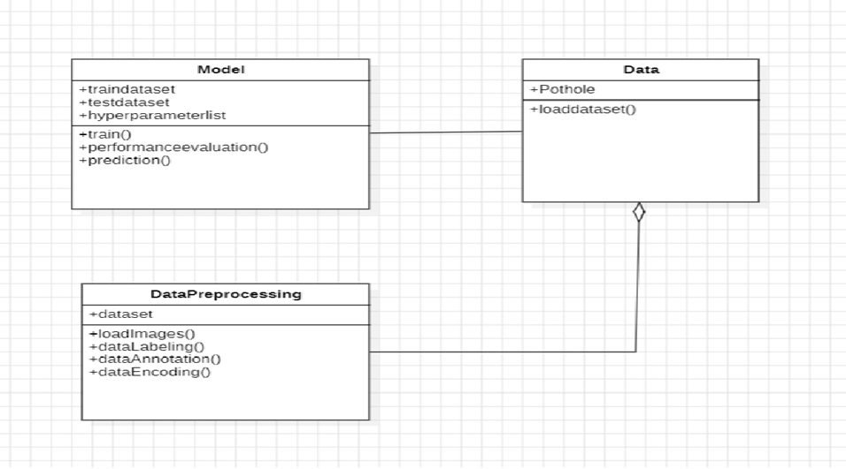

Fig 4.2: Class Diagram of Pothole Detection.

4.3.2. Use Case Diagram:
Use case diagrams model the functionality of a system using actors and use cases. Use cases are services or functions provided by the system to its users. Use case diagram is useful for representing the functional requirements of the system using various notations like system, use case, actors, and relationships.
Basic Use Case Diagram Symbols and Notations System:
Draw your system's boundaries using a rectangle that contains use cases. Place actors
outside the system's boundaries.

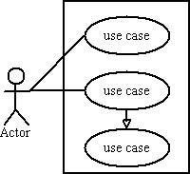

Use Case: Draw use cases using ovals. Label with ovals with verbs that represent the system's functions.

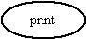
Actors:

Actors are the users of a system. When one system is the actor of another system, label the actor system with the actor stereotype.

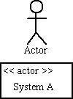

Relationships:
Illustrate relationships between an actor and a use case with a simple line. For relationships among use cases, use arrows labelled either "uses" or "extends." A "uses" relationship indicates that one use case is needed by another in order to perform a task. An "extends" relationship indicates alternative options under a certain use case.
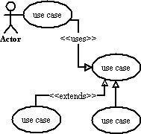

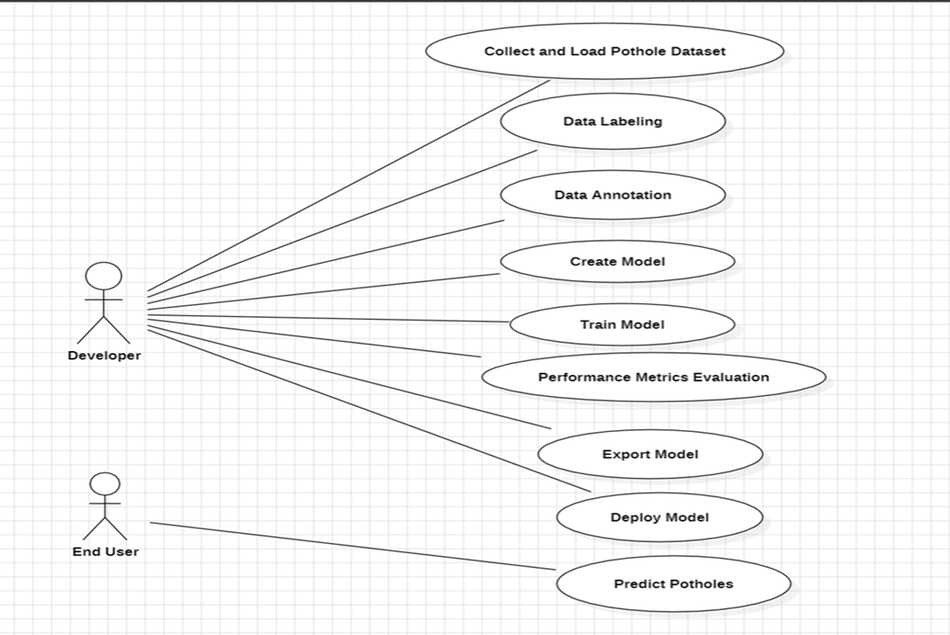

Fig 4.3: Use case Diagram of Pothole Detection.

4.3.3. Sequence Diagram:
Sequence diagrams describe interactions among classes in terms of an exchange of messages over time.
Basic Sequence Diagram Symbols and Notations:
Class roles: Class roles describe the way an object will behave in context. Use the UML object symbol to illustrate class roles, but don't list object attributes.

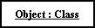

Activation:
Activation boxes represent the time an object needs to complete a task.
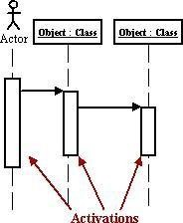

Messages:

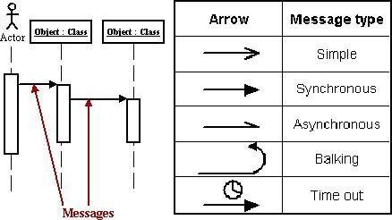

Messages are arrows that represent communication between objects. Use half-arrowed lines to represent asynchronous messages. Asynchronous messages are sent from an object that will not wait for a response from the receiver before continuing its tasks.
Lifelines:
Lifelines are vertical dashed lines that indicate the object's presence over time.

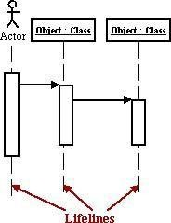

Destroying Objects:
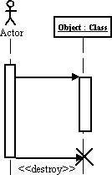
Objects can be terminated early using an arrow labeled "<< destroy >>" that points to X.

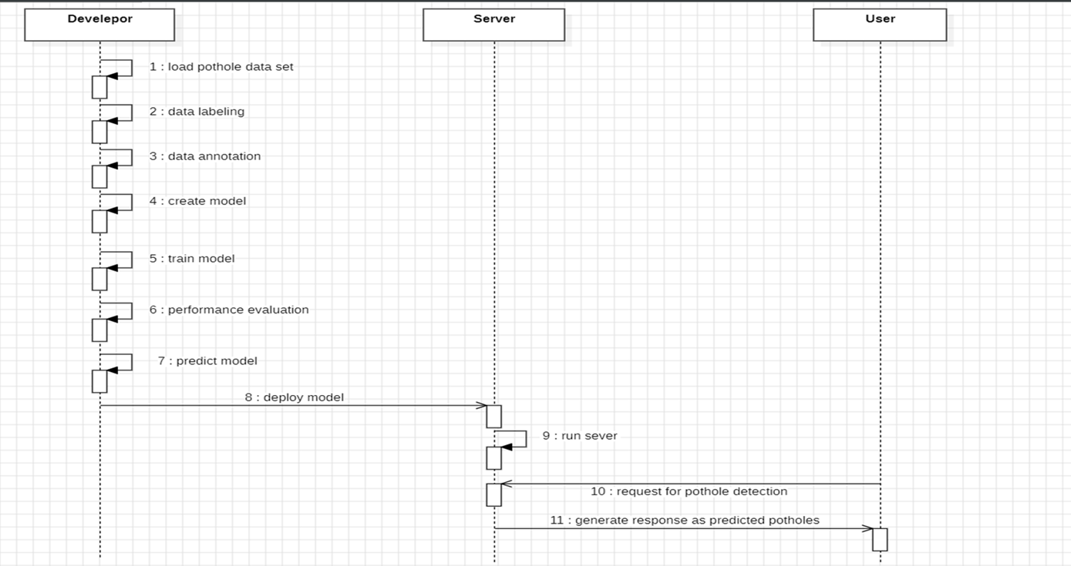

Fig 4.4: Sequence Diagram of Pothole Detection.

4.3.4. Activity Diagram:
An activity diagram illustrates the dynamic nature of a system by modelling the flow of control from activity to activity. An activity represents an operation on some class in the system that results in a change in the state of the system. Typically, activity diagrams are used to model workflow or business processes and internal operation. Because an activity diagram is a special kind of state chart diagram, it uses some of the same modelling conventions.
Basic Activity Diagram Symbols and Notations:
Action states:
Action states represent the non-interruptible actions of objects. You can draw an action state in Smart Draw using a rectangle with rounded corners.

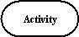

Action Flow: Action flow arrows illustrate the relationships among action states.

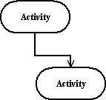

Object Flow:
Object flow refers to the creation and modification of objects by activities. An object flow arrow from an action to an object means that the action creates or influences the object.
An object flow arrow from an object to an action indicates that the action state uses the object.

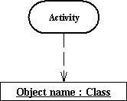

Initial State: A filled circle followed by an arrow represents the initial action state.

Final State:
An arrow pointing to a filled circle nested inside another circle represents the final action state.

Branching:
A diamond represents a decision with alternate paths. The outgoing alternates should be labelled with a condition or guard expression. You can also label one of the paths "else."

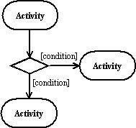

Synchronization:
In process modeling, a synchronization bar serves as a visual aid to illustrate parallel transitions within a process flow. Often referred to as forking and joining, synchronization allows for the simultaneous execution of multiple tasks or activities. It plays a crucial role in coordinating the flow of processes, ensuring that parallel activities progress smoothly and synchronously.

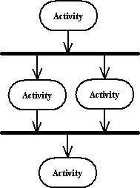

Swimlanes:
Swimlanes, on the other hand, serve as organizational elements within process diagrams, grouping related activities into distinct columns. Each swimlane typically represents a specific role, department, or entity involved in the process. By organizing
activities into swimlanes, process models become more structured and intuitive, facilitating a clearer understanding of responsibilities and dependencies. Swimlanes provide a visual framework that helps stakeholders identify the flow of activities across different entities or departments, promoting effective communication and collaboration within the organization.

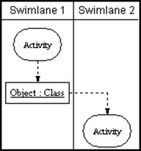

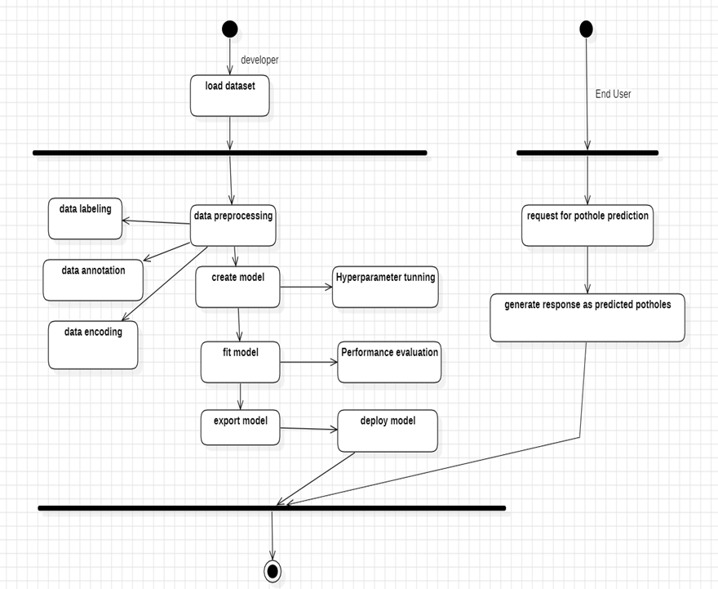

Fig 4.5: Activity Diagram of Pothole Detection.
4.3.5. System architecture:
The system architecture of the Deep Learning Based Road Pothole Detection and Monitoring System describes the overall structure of the system and the interaction between different components involved in detecting potholes using the YOLO deep learning model. The architecture mainly consists of two major modules: the training pipeline and the inference pipeline.
In the training pipeline, a dataset of road images containing potholes is first collected from different sources. These images are then annotated by marking the pothole regions with bounding boxes using annotation tools. The annotation information is stored in files such as XML or text format, which describe the coordinates and labels of the potholes present in each image. The annotation parser reads these files and converts the information into a format suitable for training the YOLO model.
After annotation processing, the dataset is divided into training and validation image sets. The training dataset is used to train the YOLO model, allowing the neural network to learn the features and patterns associated with potholes. The validation dataset is used to evaluate the model performance and ensure that the model does not overfit the training data. During the training process, the model adjusts its internal parameters to improve the detection accuracy. Once the training is completed, the system generates trained YOLO weight files, which contain the learned knowledge of pothole features.
In the inference pipeline, the trained YOLO model is used for real-time pothole detection. The system receives an input image or video frame captured from a camera or road monitoring system. The input frame undergoes preprocessing, such as resizing and normalization, to make it compatible with the YOLO model input requirements.
The processed image is then passed to the YOLO inference stage, where the trained model analyzes the image and predicts the presence of potholes. If potholes are detected, the system generates bounding boxes around the detected regions and labels them accordingly. These detections can then be displayed on the screen or stored for further monitoring and analysis.
Finally, the system can generate alerts or notifications when potholes are detected. This helps road maintenance authorities identify damaged road sections quickly and take necessary repair actions. The overall architecture ensures efficient pothole detection by combining image processing techniques with deep learning-based object detection using the YOLO algorithm.

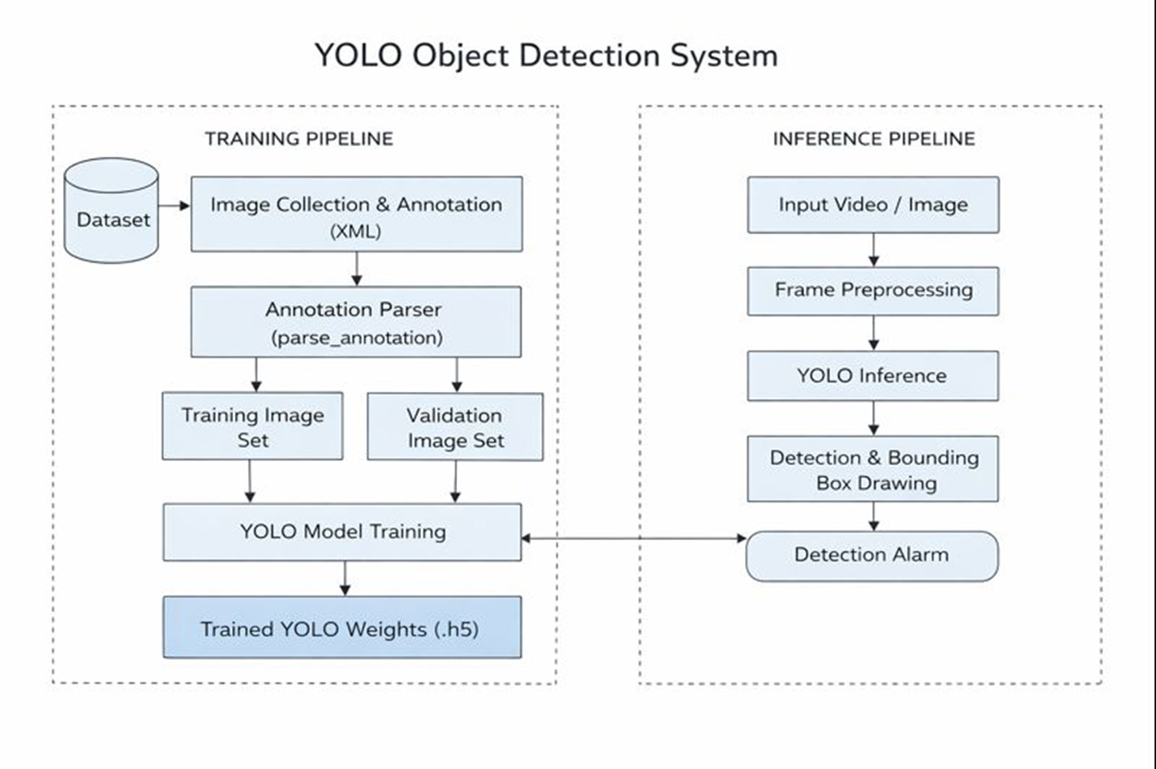

Fig 4.6: System architecture of Pothole Detection.

5. SYSTEM IMPLEMENTATION

5.1 Methodology
The implementation phase is a critical stage where the theoretical concepts of the proposed system are converted into a practical and functional application. During this phase, the developed algorithms and models are integrated to create a system capable of detecting potholes on road surfaces using deep learning techniques. The system is designed to analyze road images or video frames and identify potholes automatically.
The implementation process includes several stages such as data collection, preprocessing, model training, detection, and result visualization. These stages work together to ensure that the system performs accurate pothole detection. The YOLO (You Only Look Once) object detection algorithm is used as the core model because of its ability to perform fast and real-time object detection.
The developed system allows the user to provide road images or video inputs. These inputs are processed using image processing techniques and deep learning models. After processing, the system identifies pothole regions and highlights them using bounding boxes. This helps road maintenance authorities quickly identify damaged road areas and take necessary actions.
To ensure reliability, the system is tested using different road images under various lighting and environmental conditions. The results are evaluated to verify that the system performs efficiently and produces accurate detection results. Proper implementation ensures that the system works smoothly and can be used as an effective tool for road monitoring.
Data Processing
Data processing is the process of converting raw data into meaningful and useful information. In machine learning systems, data processing plays an important role because the quality of the data directly affects the performance of the model. The data used in this project consists of road images that may contain potholes.
Machine learning algorithms require structured and clean data in order to learn patterns effectively. Therefore, the collected images must be processed carefully before they are used for training the deep learning model. Data processing involves several steps such as data collection, data preparation, input processing, model processing, output generation, and data storage.
The output of the data processing stage can be visualized in different forms such as images with bounding boxes, charts, graphs, or reports. In the pothole detection system, the output mainly consists of images where potholes are detected and highlighted.

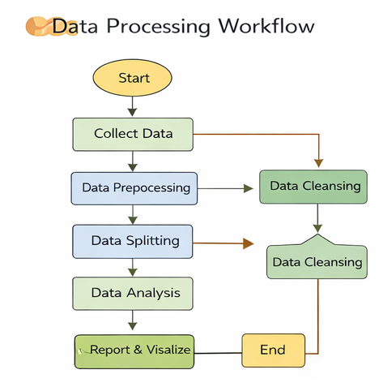
Fig 5.1: Data Processing Workflow.

Collection
The first step in machine learning is collecting a high-quality dataset. In this project, road images containing potholes are collected from various sources such as publicly available datasets, online repositories, and manually captured images using cameras.
Good quality data improves the learning capability of the model and increases the accuracy of pothole detection. A dataset with different road conditions, lighting environments, and pothole sizes helps the model learn diverse patterns.

Preparation
After collecting the data, the images are prepared for further processing. Data preparation involves organizing and analyzing the dataset to remove irrelevant information.
The images may be converted into numerical format so that they can be processed by machine learning algorithms. For example, each image is represented as a matrix of pixel values.
Input
In this stage, the prepared data is provided as input to the deep learning model. The images are converted into a format that can be processed by the neural network.
This step requires proper formatting, resizing, and normalization to ensure compatibility with the YOLO model.
Processing
During this stage, machine learning algorithms and deep learning techniques are applied to the input data. The YOLO model analyzes the images and learns the features that distinguish potholes from normal road surfaces.
The trained model then processes new images to detect potholes automatically.
Output
The output stage produces the final results of the system. The detected potholes are highlighted using bounding boxes on the input images.
This visual output allows users to easily identify pothole locations on the road.
Storage
In the final stage, the processed results and trained models are stored for future use. The stored information can be used for monitoring road conditions and improving the model in future updates.

Data Preprocessing
Data preprocessing refers to the transformations applied to raw data before it is used for training machine learning models. In many cases, raw data collected from different sources may contain noise, inconsistencies, or missing values.
Data preprocessing helps convert raw data into a clean and structured dataset suitable for analysis. Proper preprocessing improves model performance and ensures that the deep learning algorithm can learn meaningful patterns from the data.
Need for Data Preprocessing
For achieving better results in machine learning projects, the data must be organized in a proper format. Some machine learning models require data to follow specific formats, and preprocessing ensures that these requirements are met.
Another important aspect of preprocessing is enabling multiple machine learning
algorithms to work on the same dataset. This allows researchers to compare different models and choose the best performing one.
1. Rescaling Data
When a dataset contains features with different scales, many machine learning algorithms benefit from rescaling the data to a common range.
Rescaling helps optimization algorithms such as gradient descent perform more efficiently. It also improves the performance of algorithms that rely on distance measurements.
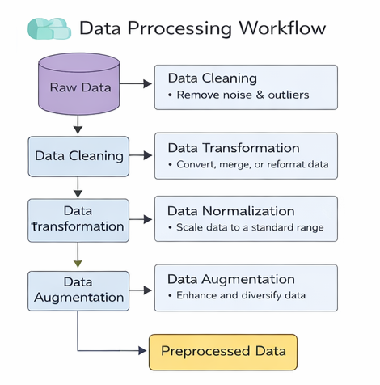
Fig 5.2: Data Preprocessing Workflow
Rescaling can be implemented using tools such as MinMaxScaler in Python libraries like scikit-learn. This technique transforms the values of features into a fixed range, usually between 0 and 1.
2. Binarizing Data
Binarization is the process of converting numerical values into binary values (0 or 1) based on a threshold. Values above the threshold are assigned the value 1, while values below the threshold are assigned 0.
This technique is useful when creating new features that indicate the presence or absence of certain characteristics in the dataset.
3. Standardizing Data
Standardization transforms data so that it follows a normal distribution with a mean of zero and a standard deviation of one. This technique helps machine learning models perform better when dealing with features that have different ranges.
Standardization can be implemented using tools such as StandardScaler in Python.
Data Cleansing
Data cleansing is an important step in the machine learning pipeline. It involves identifying and correcting errors or inconsistencies in the dataset.
Clean data is essential for building reliable machine learning models. Even a simple algorithm can perform well when trained on high-quality data.
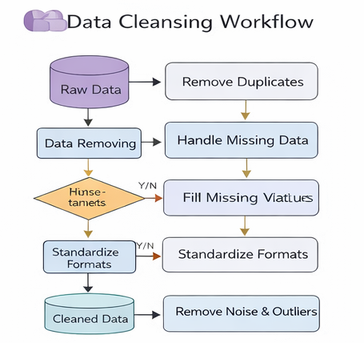
Fig 5.3: Data Cleansing Workflow
Steps Involved in Data Cleaning
1. Removal of Unwanted Observations
This step involves removing duplicate or irrelevant data from the dataset. Duplicate entries can reduce the efficiency of the model and produce inaccurate results.
Irrelevant data that does not contribute to the problem being solved should also be removed.
2. Fixing Structural Errors
Structural errors occur when there are inconsistencies in the dataset, such as different naming formats or incorrect labels.
For example, variations in capitalization or spelling can cause the model to treat the same value as different categories.
3. Managing Outliers
Outliers are extreme values that differ significantly from other observations in the dataset. These values can negatively affect the performance of certain machine learning models.
Outliers should only be removed if there is a valid reason, such as measurement errors.
4. Handling Missing Data
Missing data is a common issue in datasets. Missing values must be handled carefully because they can affect the performance of the model.
Two common approaches include removing incomplete observations or filling missing values using statistical methods such as mean or median values.
Python
Python is a high-level programming language that is designed to be simple, readable, and easy to use. It is an open-source programming language, which means it is freely available for both personal and commercial use. Python can run on multiple platforms such as Windows, Mac, and Unix systems, making it a highly portable programming language.
Python is widely used in various fields such as web development, data science, machine learning, artificial intelligence, and automation. It is also used in many 2D and 3D image processing applications. Popular software such as GIMP, Blender, and Autodesk Maya support Python APIs, which allow developers to create custom plug-ins and extensions.
Python programs are written in files with the .py extension. These scripts can be executed directly by the Python interpreter. Python programs can also be compiled into .pyc files, which are bytecode files used as modules that can be reused by other Python programs.
Python is widely used in machine learning and deep learning applications because it provides powerful libraries such as NumPy, TensorFlow, Keras, and OpenCV that simplify the development of intelligent systems.
Features of Python
Python provides several features that make it one of the most popular programming languages in the world.
Easy to Learn and Use
Python is considered one of the easiest programming languages to learn. Its syntax is simple and similar to the English language. Unlike many other languages, Python does not require semicolons or curly brackets; instead, indentation is used to define code blocks.
Expressive Language
Python allows programmers to perform complex operations using fewer lines of code. For example, a simple program such as printing “Hello World” can be written using a single line of code:
print("Hello World").
Interpreted Language
Python is an interpreted language, meaning that the code is executed line by line. This makes debugging easier and allows developers to quickly test and modify their programs.
Cross-Platform Language
Python programs can run on multiple operating systems including Windows, Linux, Unix, and MacOS without major changes to the code. This makes Python highly portable.
Free and Open Source
Python is freely available and maintained by a large community of developers. Anyone can download Python from its official website and use it without any licensing cost.
Object-Oriented Programming Support
Python supports object-oriented programming concepts such as classes, objects, inheritance, encapsulation, and polymorphism. These features help developers create reusable and maintainable code.
Extensible and Integrated
Python can easily integrate with other programming languages such as C, C++, and Java. Developers can write performance-critical parts of an application in other languages and integrate them with Python.
Large Standard Library
Python provides a large collection of built-in libraries and frameworks for different tasks. Libraries such as NumPy, TensorFlow, Pandas, OpenCV, and Keras are commonly used in machine learning and data analysis.
GUI Programming Support
Python also supports the development of graphical user interface applications using libraries such as Tkinter, PyQt5, and Kivy.
Dynamic Memory Allocation
In Python, memory is allocated automatically at runtime. Programmers do not need to declare the data type of variables explicitly, which simplifies programming and reduces errors.
Jupyter Notebook
Jupyter Notebook is an open-source web-based interactive environment used for developing and executing Python programs. It allows users to create and share documents that include live code, equations, visualizations, and explanatory text.
Jupyter Notebook is widely used in data science, machine learning, and research because it provides an interactive platform where developers can write code, execute it step by step, and visualize results immediately. It supports multiple programming languages such as Python, R, Julia, and others.
Advantages of Jupyter Notebook
All-in-One Environment
Jupyter Notebook combines code, text, visualizations, and multimedia elements into a single document, making it easier to manage and present data analysis projects.
Easy Conversion
Jupyter notebooks can easily be converted into various formats such as HTML, PDF, and Markdown, which makes it convenient for sharing reports and presentations.
Easy Sharing
Notebook files can be shared easily with others because they are saved in a structured text format. This allows collaboration among researchers and developers.
Language Independent
Jupyter Notebook supports multiple programming languages, making it a flexible tool for different programming environments.
Interactive Code Execution
Jupyter allows users to run code cell by cell, which helps in debugging and experimenting with data. It also supports interactive widgets that help visualize and explore data more effectively.
5.1 Model Information
Object detection is an important task in computer vision that focuses on identifying and locating objects present in an image. Deep learning techniques have significantly improved the performance of object detection systems. These systems can analyze images and detect objects by placing bounding boxes around them and assigning class labels.
Several deep learning models have been developed for object detection, including R-CNN, Fast R-CNN, and Faster R-CNN. These models have gradually improved detection accuracy and speed by introducing better architectures and feature extraction methods. In this project, advanced deep learning techniques are used to detect objects effectively from image datasets.

The notebook environment enables users to combine programming code with documentation, making it easier to understand and reproduce experiments. It is commonly used for tasks such as data cleaning, statistical analysis, data visualization, and machine learning model development.
Jupyter notebooks are saved in JSON format, which makes them easy to share and convert into different formats such as HTML and PDF.
5.1.1 Module Description
R-CNN Model
The Region-based Convolutional Neural Network (R-CNN) is one of the earliest deep learning models developed for object detection tasks. This model works by dividing the input image into multiple regions of interest (RoIs). Each region is then passed through a convolutional neural network (CNN) to extract important features.
After feature extraction, these features are processed by a region proposal network that predicts possible bounding boxes where objects may exist. Finally, the model uses a classifier to identify the object category and a bounding box regressor to refine the position of the detected object.
R-CNN is known for providing high detection accuracy. However, the model is computationally expensive because it processes each region separately. Due to this multi-stage architecture, the inference speed of R-CNN is relatively slow.
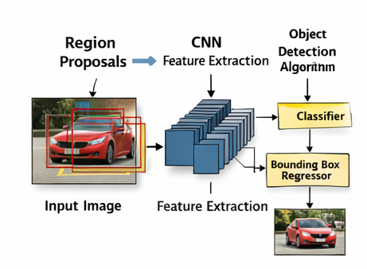
Fig 5.4: R-CNN Architecture

Fast R-CNN Model
Fast R-CNN is an improved version of the R-CNN model designed to overcome the speed limitations of the original architecture. Instead of processing each region separately, Fast R-CNN extracts features from the entire image using a convolutional neural network.
After generating the feature map, region proposals are applied on the feature map using a Region of Interest (RoI) pooling layer. This method allows multiple region proposals to share the same convolutional features, significantly reducing the computational cost.
Fast R-CNN improves detection speed and also enhances classification accuracy by combining classification and bounding box regression into a single model.
Faster R-CNN Model
Faster R-CNN further enhances the object detection process by introducing a Region Proposal Network (RPN). The RPN generates region proposals directly from convolutional feature maps without using external algorithms like selective search.
This improvement allows the entire model to be trained end-to-end, which increases both efficiency and detection performance. Faster R-CNN is widely used in many computer vision applications because it provides a good balance between accuracy and speed.
Mask R-CNN Model
Mask R-CNN is an extension of the Faster R-CNN model that adds an additional branch for predicting segmentation masks for each detected object. In addition to object detection and classification, Mask R-CNN can also perform pixel-level segmentation.
This capability makes Mask R-CNN useful for applications that require precise object boundaries, such as medical image analysis and autonomous driving systems.
Modules of Mask R-CNN
1) Region Proposal Network (RPN)
The Region Proposal Network is a lightweight neural network that scans the backbone feature map using a sliding window approach. It generates anchor boxes that represent possible object locations in the image.
Each anchor is evaluated to determine whether it contains an object or background. The RPN outputs two values: the object classification score and the bounding box refinement.
2) Refined Bounding Boxes
To improve the accuracy of object localization, Mask R-CNN introduces the RoIAlign layer, which replaces the traditional RoIPool layer. RoIAlign removes the quantization issues of RoIPool and ensures that the extracted features precisely align with the original image.
This refinement improves the quality of bounding boxes and ensures more accurate object detection.
3) Instance Masks
The mask branch in Mask R-CNN is responsible for generating segmentation masks for each detected object. This branch uses a convolutional neural network to predict a small mask (typically 28 × 28 pixels) for each object.
Unlike binary masks, these masks contain floating-point values that capture more detailed information about object boundaries.
Working Steps of Mask R-CNN
The working process of Mask R-CNN includes the following steps:
• The Region Proposal Network is trained end-to-end using a pre-trained CNN model.
• Positive and negative samples are determined using the Intersection over Union (IoU)metric.
• The IoU is calculated using the formula:
IoU = |G ∩ P| / |G ∪ P|
Where
G = Ground truth bounding box
P = Predicted bounding box
• A small sliding window scans the convolutional feature map of the image.
• Anchor boxes are generated at each sliding position to predict possible object regions.
• These proposals are used to train the object detection model.
• The network is fine-tuned based on the object class labels.
Transfer Learning and Dataset
For transfer learning, pre-trained weights from the COCO dataset were used and adapted for detecting potholes in road images. The dataset used in this project consists of 247 images collected from multiple sources.
The training dataset includes:
- 50 images from CCSAD Urban Sequence 1
- 100 images from DLR dataset
- 48 images from Japan dataset
- 49 images from Sunny dataset
A validation dataset of 50 images was also used during training. For testing purposes, 50 images from CCSAD Sequence 2 and PNW dataset were selected.
Data augmentation techniques such as left-right image flipping were applied to increase the dataset size and improve model performance.
5.2 Python Libraries
Python provides several powerful libraries that simplify the development of machine learning and computer vision applications. These libraries provide tools for numerical computation, data manipulation, deep learning model development, and image processing.
The major libraries used in this project include NumPy, TensorFlow, Keras, and OpenCV.
5.2.1 Libraries Description
NumPy
NumPy stands for Numerical Python and is one of the most important libraries used for scientific computing in Python. It provides support for multidimensional arrays and mathematical operations on these arrays.
NumPy was developed by Travis Oliphant in 2005 by combining the features of two earlier libraries: Numeric and Numarray.
Operations Using NumPy
Using NumPy, developers can perform several operations such as:
• Mathematical and logical operations on arrays
• Fourier transforms and signal processing
• Linear algebra operations
• Random number generation
NumPy is often used along with libraries such as SciPy and Matplotlib. Together, they form a powerful alternative to MATLAB for scientific computing.


Fig 5.5: Uses of NumPy
TensorFlow
TensorFlow is an open-source machine learning framework developed by Google. It provides a comprehensive ecosystem of tools and libraries for building and training deep learning models.
TensorFlow supports various machine learning techniques including neural networks, convolutional networks, and recurrent neural networks. It is widely used in applications such as image recognition, natural language processing, and robotics.

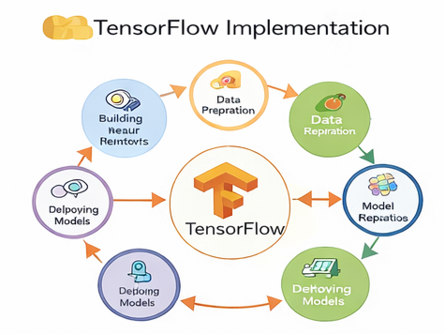
Fig 5.6: TensorFlow Implementation
Keras
Keras is a high-level deep learning API built on top of TensorFlow. It is designed to simplify the process of building neural networks by providing easy-to-use functions and modular components.
Keras allows developers to build deep learning models quickly with minimal code. It is widely used in research and industry because of its simplicity and flexibility.
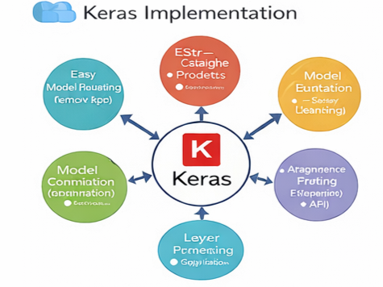
Fig 5.7: Keras Implementation
OpenCV
OpenCV (Open Source Computer Vision Library) is a powerful open-source library used for computer vision and image processing tasks. It provides a wide range of algorithms for analyzing images and videos.
Originally developed by Intel in 1999, OpenCV is widely used in applications such as object detection, face recognition, motion tracking, and robotics.
Key Features of OpenCV
- Image processing tools such as filtering, edge detection, and image enhancement.
- Object detection and recognition using machine learning algorithms.
- Feature extraction techniques for object tracking and image matching.
- Camera calibration and 3D reconstruction capabilities.
- Integration with deep learning frameworks like TensorFlow and PyTorch.
- Cross-platform support for Windows, Linux, macOS, Android, and iOS.

Installation of Python Packages
The pip package manager is used to install Python libraries.

Installation Steps
• First install Python on the system.
• Pip is automatically installed with Python.
• Open Command Prompt and run the following commands:
pip install package_name
or
python -m pip install package_name
Uninstalling Python Packages
To remove installed packages, use the following command:
pip uninstall package_name
After running the command, confirm the uninstallation by typing y or yes.

6.RESULT

This chapter presents the results obtained from the implementation of the proposed system. The system was tested using different image datasets to evaluate its ability to detect potholes accurately. The output results demonstrate the effectiveness of the deep learning model used in this project.
The performance of the model is analyzed based on detection accuracy, bounding box prediction, and segmentation results. In addition, comparisons with other detection approaches and evaluation metrics are discussed to validate the efficiency of the proposed system.
6.1 Output
The output of the system shows the successful detection of potholes from input road images. The trained Mask R-CNN model processes the input image and identifies pothole regions by drawing bounding boxes and segmentation masks around them.
When an input image is provided to the system, the model first extracts features using a convolutional neural network. Then the Region Proposal Network generates possible object regions. These regions are further classified and refined to accurately detect potholes.
The detected potholes are highlighted in the output image along with their bounding boxes and masks. This visual representation helps in clearly identifying damaged road areas.
The output results demonstrate that the system can effectively detect potholes under different lighting conditions, road textures, and image angles.
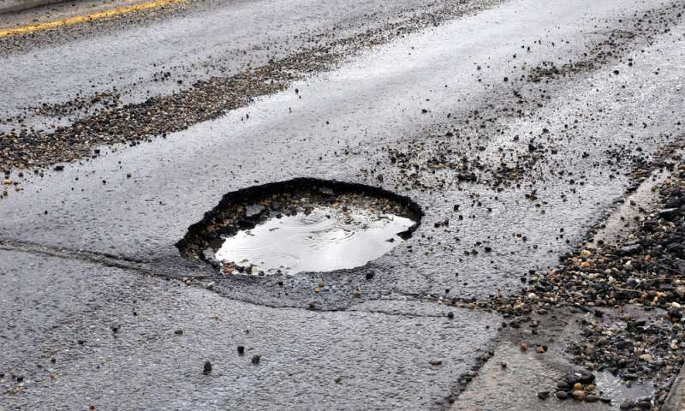
Fig 6.1: Input Road Image
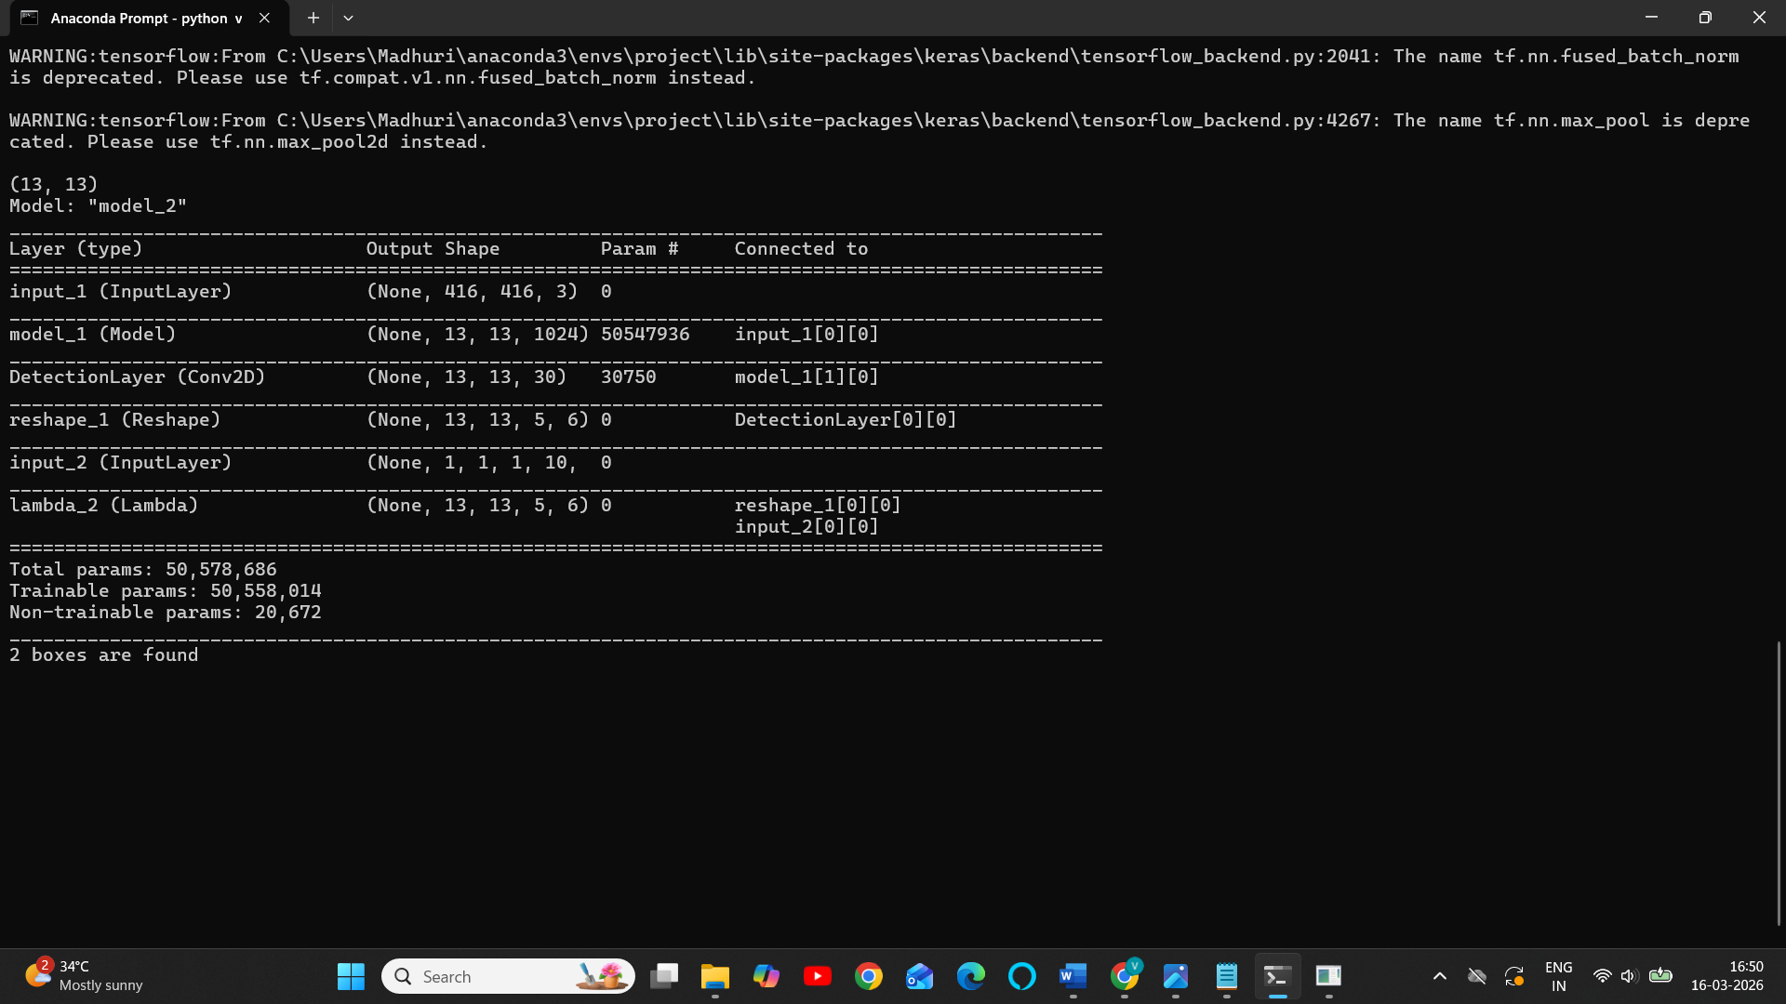
Fig 6.2 Inputting image or video

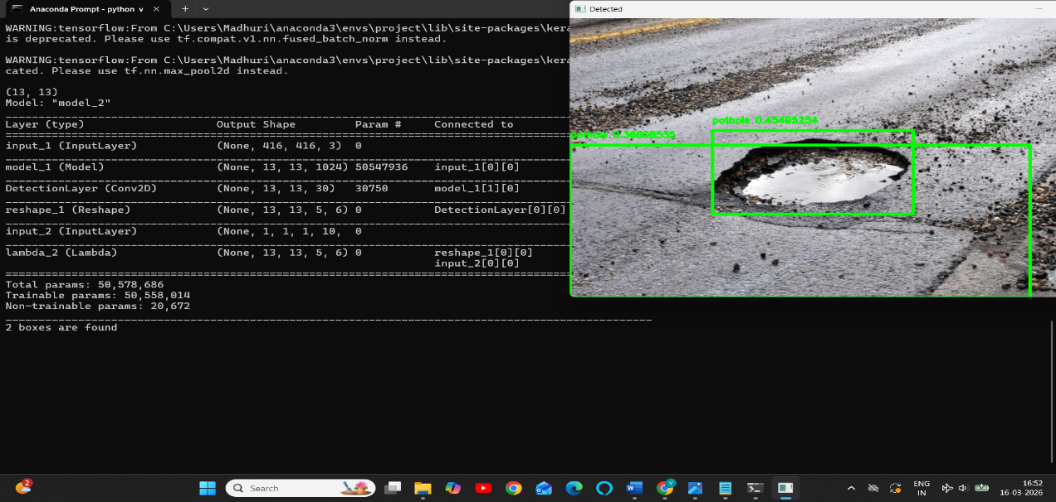
Fig 6.3 Detection of Pothole from Input image
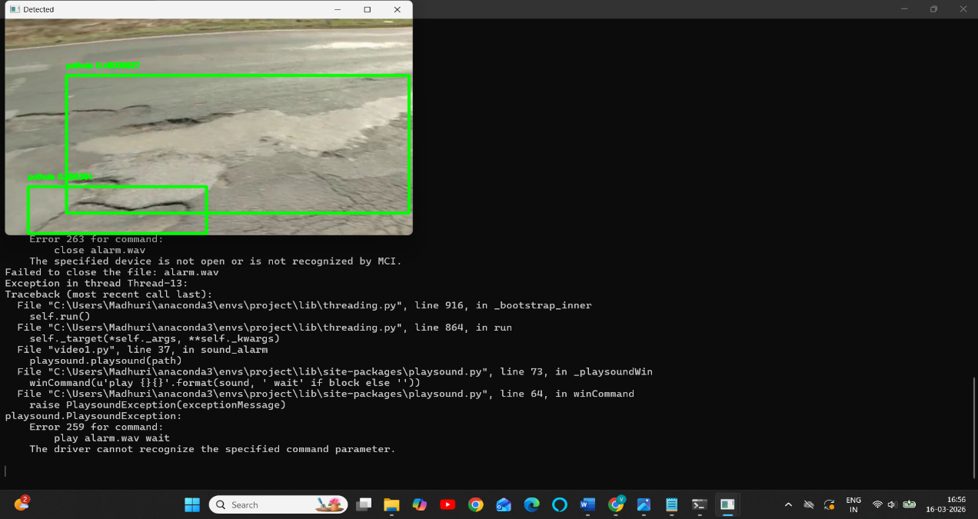
Fig 6.4: Detection of Pothole from Input Video
6.2 Comparison
To evaluate the effectiveness of the proposed system, the results are compared with traditional object detection models such as R-CNN, Fast R-CNN, and Faster R-CNN.
The comparison shows that the Mask R-CNN model provides better detection performance because it not only detects objects but also provides pixel-level segmentation. This allows more precise identification of pothole regions compared to other models.
R-CNN provides high accuracy but requires more computational time because it processes each region separately. Fast R-CNN improves speed by sharing convolutional features across region proposals. Faster R-CNN further improves performance by introducing a Region Proposal Network.
However, Mask R-CNN extends Faster R-CNN by adding a mask prediction branch, enabling the system to perform instance segmentation in addition to object detection.
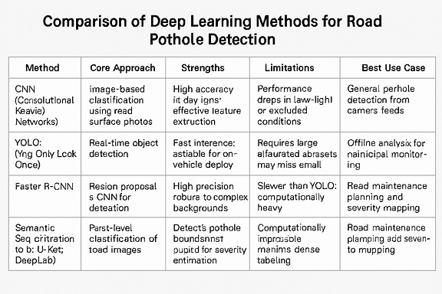
Table 6.1 Comparison Table
6.3 Performance Metrics
To evaluate the performance of the pothole detection system, several evaluation metrics are used. These metrics help measure the accuracy and effectiveness of the trained model.
1. Precision
Precision measures the accuracy of positive predictions made by the model. It indicates how many of the detected potholes are actually correct.
Precision is calculated as:
Precision = TP / (TP + FP)
Where:
TP = True Positives
FP = False Positives
2. Recall
Recall measures the ability of the model to detect all actual potholes present in the dataset.
Recall is calculated as:
Recall = TP / (TP + FN)
Where:
FN = False Negatives
3. F1 Score
The F1 Score is the harmonic mean of precision and recall. It provides a balanced measure of the model’s performance.
F1 Score = 2 × (Precision × Recall) / (Precision + Recall)
4. Intersection over Union (IoU)
Intersection over Union is used to measure the overlap between the predicted bounding box and the ground truth bounding box.
IoU = |G ∩ P| / |G ∪ P|
Where
G = Ground truth bounding box
P = Predicted bounding box
5. Mean Average Precision (mAP)
Mean Average Precision is a common metric used in object detection tasks. It evaluates the overall detection performance by calculating the average precision across all object classes.
A higher mAP value indicates better detection performance.

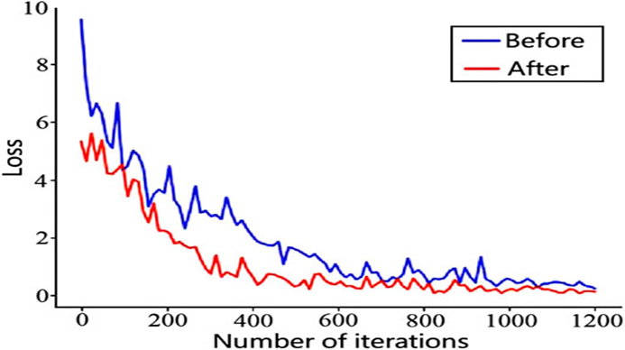
Fig.6.6 Loss Function at different iterations

7.SYSTEM TESTING

System testing is an important phase in the software development process that ensures the developed system works correctly and meets the specified requirements. It involves testing the complete system to verify that all modules function properly when integrated together.
In this project, system testing is performed to evaluate the performance of the pothole detection system. The testing process verifies whether the system correctly detects potholes from input road images and produces accurate outputs. Various test cases were used to check the reliability, efficiency, and accuracy of the implemented model.
The system was tested using different road images containing potholes under various conditions such as different lighting environments, road textures, and camera angles.
7.1 Testing Objectives
The main objectives of system testing are:
• To verify that the system detects potholes accurately.
• To ensure that the system processes input images correctly.
• To validate that the output results are generated without errors.
• To check the performance and reliability of the detection model.
• To ensure the system meets the functional requirements of the project.
7.2 Types of Testing
Unit Testing
Unit testing involves testing individual modules of the system separately. Each module of the pothole detection system, such as image input, preprocessing, feature extraction, and detection, was tested independently to ensure proper functionality.
Integration Testing
Integration testing verifies the interaction between different modules of the system. In this stage, modules such as the image processing module, detection model, and output visualization module were integrated and tested to ensure they work together smoothly.
System Testing
System testing evaluates the complete system as a whole. The pothole detection system was tested using various road images to confirm that the entire workflow—from input image to pothole detection output—operates correctly.
Performance Testing
Performance testing checks the efficiency and speed of the system. The detection model was evaluated based on how quickly it processes images and how accurately it identifies potholes.
7.3 Test Cases
Test Case ID | Input | Expected Output | Actual Output | Result
TC1 | Road image with pothole | Pothole detected with bounding box | Detected correctly | Pass
TC2 | Road image without pothole | No detection | No pothole detected | Pass
TC3 | Multiple potholes image | All potholes detected | Detected correctly | Pass
TC4 | Low light road image | Pothole detected | Detected with minor variation | Pass
7.4 Testing Results
The testing results indicate that the pothole detection system performs effectively under various conditions. The Mask R-CNN model successfully detects potholes and highlights them with bounding boxes and segmentation masks.
The system demonstrated high accuracy in identifying potholes in different types of road images. Minor variations were observed in cases with poor lighting conditions, but overall detection performance remained reliable.
7.5 Summary
The system testing phase confirmed that the proposed pothole detection system functions as expected. The testing process validated the accuracy, reliability, and efficiency of the system.
The successful results obtained from testing demonstrate that the system can effectively detect potholes and assist in identifying damaged road areas.

8.CONCLUSION
In this project, a pothole detection system was developed using deep learning techniques. The system utilizes the Mask R-CNN model to identify potholes from road images effectively. The model analyzes the input images, detects pothole regions, and highlights them using bounding boxes and segmentation masks, which helps in clearly identifying the damaged areas on roads.
The system was trained using multiple datasets collected from different sources and tested on various road images to evaluate its performance. Experimental results show that the model is capable of detecting potholes accurately under different environmental conditions such as varying lighting, road textures, and camera angles.
The developed pothole detection system can be highly useful for road maintenance authorities and municipal organizations. It can assist in quickly identifying damaged road areas and planning timely repairs. Early detection of potholes can help reduce road accidents, prevent vehicle damage, and improve transportation safety.
The implementation of deep learning models such as Mask R-CNN improves the efficiency of pothole detection systems. It reduces manual inspection efforts and enables automated monitoring of road conditions. This can significantly support smart city initiatives and intelligent transportation systems.
In addition, the use of image processing and machine learning techniques helps in analyzing road conditions more effectively. The system can process large numbers of images and detect potholes with better precision, making it suitable for large-scale road monitoring applications.
Overall, the proposed system demonstrates that deep learning techniques can be effectively applied to real-world problems like road damage detection. The system provides a reliable and scalable solution that can contribute to better road maintenance and improved public safety.

9.FUTURE SCOPE
In the future, the pothole detection system can be improved by integrating real-time video processing for continuous road monitoring. The system can also be combined with GPS technology to automatically record the location of detected potholes.
A mobile application can be developed so that users can capture road images and detect potholes instantly. Increasing the size of the training dataset and using more advanced deep learning models can further improve the accuracy and performance of the system.
The system can also be integrated with cloud technology to store and manage large amounts of road data. This will allow authorities to access the collected information easily and monitor road conditions from different locations.
Another possible improvement is integrating the system with smart city infrastructure.
The detected pothole data can be automatically sent to municipal departments so that repair work can be scheduled quickly and efficiently.
In the future, advanced deep learning architectures and optimization techniques can be used to improve detection speed and accuracy. This will help the system work efficiently even with large datasets and real-time applications.
The system can also be integrated with vehicle-mounted cameras or dashboard cameras to automatically capture road images while driving. This will allow continuous monitoring of roads without requiring manual data collection.
Furthermore, the use of artificial intelligence and automation can help in developing intelligent road monitoring systems that can predict road damage before it becomes severe. This will help in preventive maintenance and improve overall road safety.

10.REFERENCES
• e, K., Gkioxari, G., Dollár, P., and Girshick, R., “Mask R-CNN,” Proceedings of the IEEE International Conference on Computer Vision (ICCV), 2017.
• Girshick, R., “Fast R-CNN,” Proceedings of the IEEE International Conference on Computer Vision (ICCV), 2015.
• Ren, S., He, K., Girshick, R., and Sun, J., “Faster R-CNN: Towards Real-Time Object Detection with Region Proposal Networks,” IEEE Transactions on Pattern Analysis and Machine Intelligence, 2016.
• TensorFlow Documentation, “An Open-Source Machine Learning Framework,” Available: https://www.tensorflow.org
• OpenCV Documentation, “Open Source Computer Vision Library,” Available: https://opencv.org
• NumPy Documentation, “Numerical Computing in Python,” Available: https://numpy.org
• Keras Documentation, “Deep Learning API for Neural Networks,” Available: https://keras.io
• Redmon, J., Divvala, S., Girshick, R., and Farhadi, A., “You Only Look Once: Unified, Real-Time Object Detection,” IEEE Conference on Computer Vision and Pattern Recognition (CVPR), 2016.

